Pizza Sales SQL Queries
- KPI’s
- Total Revenue:
select SUM(total_price) as Total_Revenue from pizza_sales;
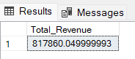

- Average Order Value:
select SUM(total_price) / COUNT(Distinct order_id) as Avg_Order_Value from pizza_Sales
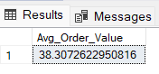

- Total Pizzas Sold:
select SUM(quantity) as Total_Pizzas_Sold from pizza_sales;
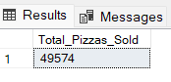

- Total Orders:
select COUNT(distinct(order_id)) as Total_Orders from pizza_sales;
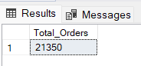

- Average Pizzas Per Order:
select Round(SUM(quantity) / COUNT(DISTINCT order_id),2) as Avg_Pizzas_Per_Order from pizza_sales;
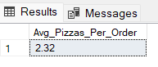

- Daily Trend for Total Orders
Select DATENAME(DW, order_date) as Order_Day, COUNT(DISTINCT order_id) as Total_Orders
from pizza_sales
GROUP BY DATENAME(DW, order_date)
ORDER BY (Total_Orders) DESC;
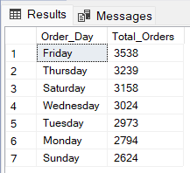

- Monthly Trend for Total Orders
Select DATENAME(MONTH, order_date) as Month_Name, COUNT(DISTINCT order_id) as
Total_Orders
from pizza_sales
GROUP BY DATENAME(MONTH, order_date)
ORDER BY (Total_Orders) DESC;
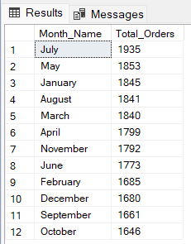

- Percentage Of Sales by Pizza Category
select pizza_category,ROUND(SUM(total_price),2) as Total_Sales, ROUND(SUM(total_price) * 100 / (select SUM(total_price) from pizza_sales),2) as PCT
from pizza_sales
GROUP BY pizza_category
ORDER BY PCT DESC;
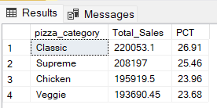

- Percentage Of Pizza Sales by Size
select pizza_size,ROUND(SUM(total_price),2) as Total_Sales, ROUND(SUM(total_price) * 100 / (select SUM(total_price) from pizza_sales),2) as PCT
from pizza_sales
GROUP BY pizza_size
ORDER BY PCT DESC;
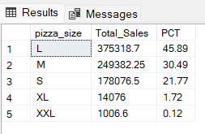

- Total Pizzas Sold by Pizza Category
select pizza_category,SUM(quantity) as Total_Pizzas_Sold from pizza_sales
GROUP BY pizza_category
ORDER BY Total_Pizzas_Sold DESC;
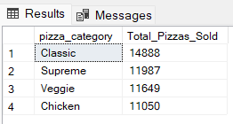

- Top 5 Pizzas by Revenue
select TOP 5 pizza_name, SUM(total_price) as Total_Revenue from pizza_sales
GROUP BY pizza_name
ORDER BY Total_Revenue DESC;
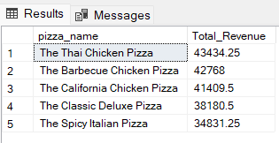

- Bottom 5 Pizzas by Revenue
select TOP 5 pizza_name, ROUND(SUM(total_price),1) as Total_Revenue from
pizza_sales
GROUP BY pizza_name
ORDER BY Total_Revenue ASC;
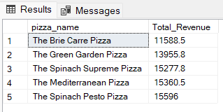

- Top 5 Pizzas by Quantity
select TOP 5 pizza_name, ROUND(SUM(quantity),1) as Total_Quantity from pizza_sales
GROUP BY pizza_name
ORDER BY Total_Quantity DESC;
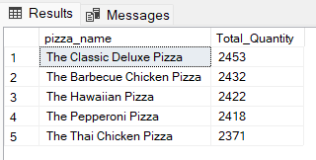

- Bottom 5 pizzas by Quantity
select TOP 5 pizza_name, ROUND(SUM(quantity),1) as Total_Quantity from pizza_sales
GROUP BY pizza_name
ORDER BY Total_Quantity ASC; 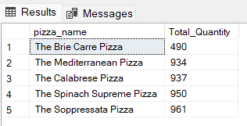

- Top 5 Pizzas by Total Orders
select TOP 5 pizza_name, COUNT(DISTINCT order_id) as Total_Orders from pizza_sales
GROUP BY pizza_name
ORDER BY Total_Orders DESC;
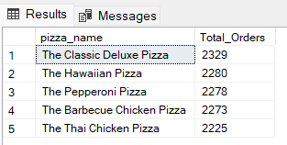

- Bottom 5 Pizzas by Total Orders
select TOP 5 pizza_name, COUNT(DISTINCT order_id) as Total_Orders from pizza_sales
GROUP BY pizza_name
ORDER BY Total_Orders ASC;
